The 10th Workshop on Digital Fluid Power, February 28–March 1, 2019, Linz, Austria

INSTRUCTIONS FOR AUTHORS

Dr. Bernd Winkler
Linz Center of Mechatronics
Altenbergerstraße 69, 4040 Linz, Austria
E-mail: bernd.winkler@lcm.at
Phone: +43 732 2468 6050, Fax: +43 732 2468 6005

ABSTRACT

The paper describes the typing instructions for preparation of papers for the 10th Workshop on Digital Fluid Power in Linz 2019. Please note that this sheet follows the instructions given below, as an example.

KEYWORDS: Layout, Typing instructions

INSTRUCTIONS FOR AUTHORS
Papers, written in English, should be submitted via email (dfp.imh@jku.at) not later than 8th February 2019. The format of the paper is Microsoft Word 2013 or earlier. The recommended length of the article is 7-20 pages.
The both margins justifying is recommended. The first page must bear the title of the workshop (Times New Roman, Italic, font size 12, centered), the title of the paper, the name(s) of the author(s), the name and address of the institution where the work was carried out and permanent address(es) of the author(s) where they differ from the institution address. All should be in the center and on the top of the first page.

Abstract
Each paper should be preceded by an abstract, the maximum length of that is 15 typed lines.

Headings
Principal headings should be numbered consecutively 1, 2, 3, …, etc. Subheadings should be numbered 1.1, 1.2, etc and 1.1.1, 1.1.2, etc.

Formulas and equations
Formulas and equations must be clearly written, each on its own line, well separated from the text. They should be numbered consecutively through the whole text with the numbering in parenthesis to the right of the formula.

Units
SI units should be used in the articles.

Figures and tables
Include your figures and tables at the appropriate place in the paper. Do not put them all at the end! Figures and tables should be numbered separately and consecutively with Arabic numerals. Use at least 300 dpi resolution (see Fig. 1).

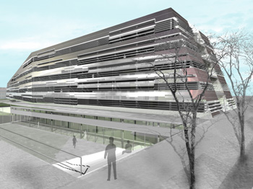
Fig. 1: Picture of JKU Science Park Linz

Text
The text font is recommended to be the Times New Roman. The title of the paper is to be written in font size 14. The text must have font size 12 and single spacing. All subheadings must be separated by double spacing.

References
References should be numbered consecutively, in order of first appearance in the text. The reference number is recommended to be put within square brackets [1] on the text line.

COPYRIGHT
It is the liability of the authors to make sure that any of the materials they submit to this conference do not violate the rights of copyright of any third party.

